Assignment

1. **Create a virtual network with 2 subnets. Each subnet should have 16 Ips only**

Log in to the AWS Management Console and open the Amazon VPC (Virtual Private Cloud) service

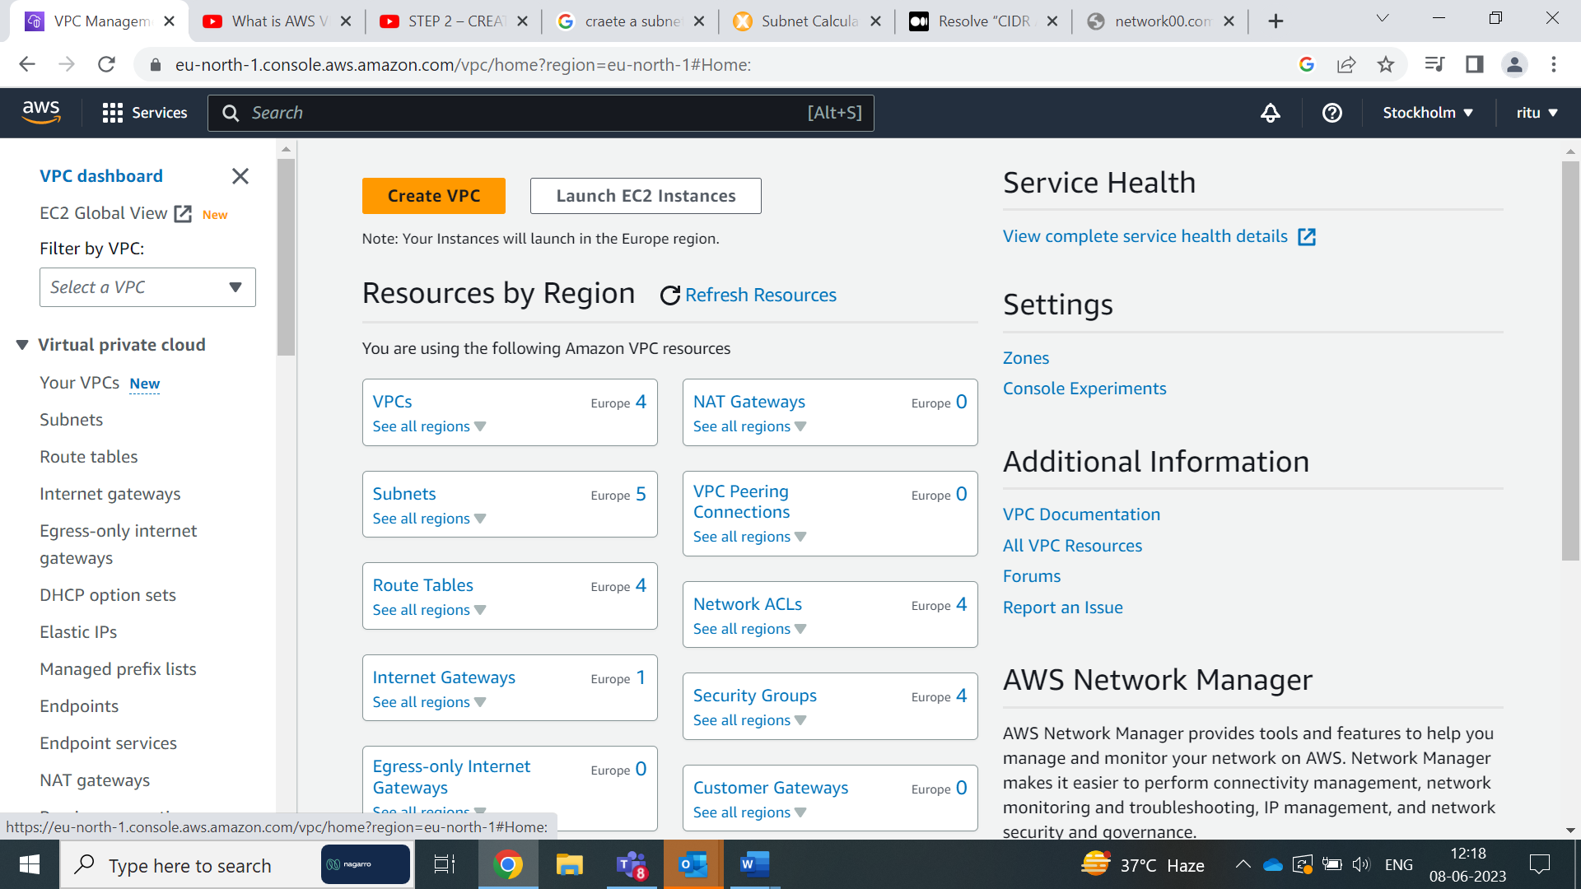

Click on Create VPC

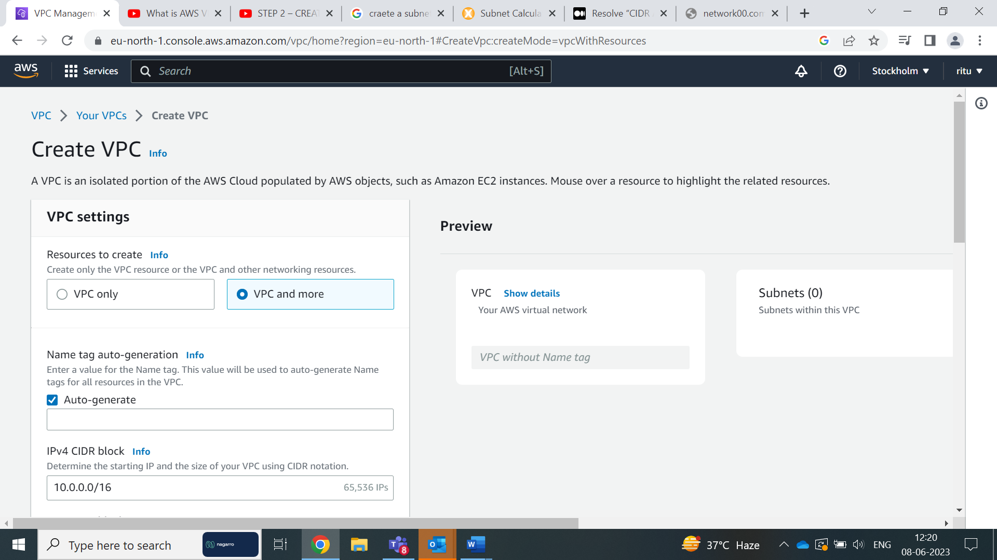

Select vpc and more options

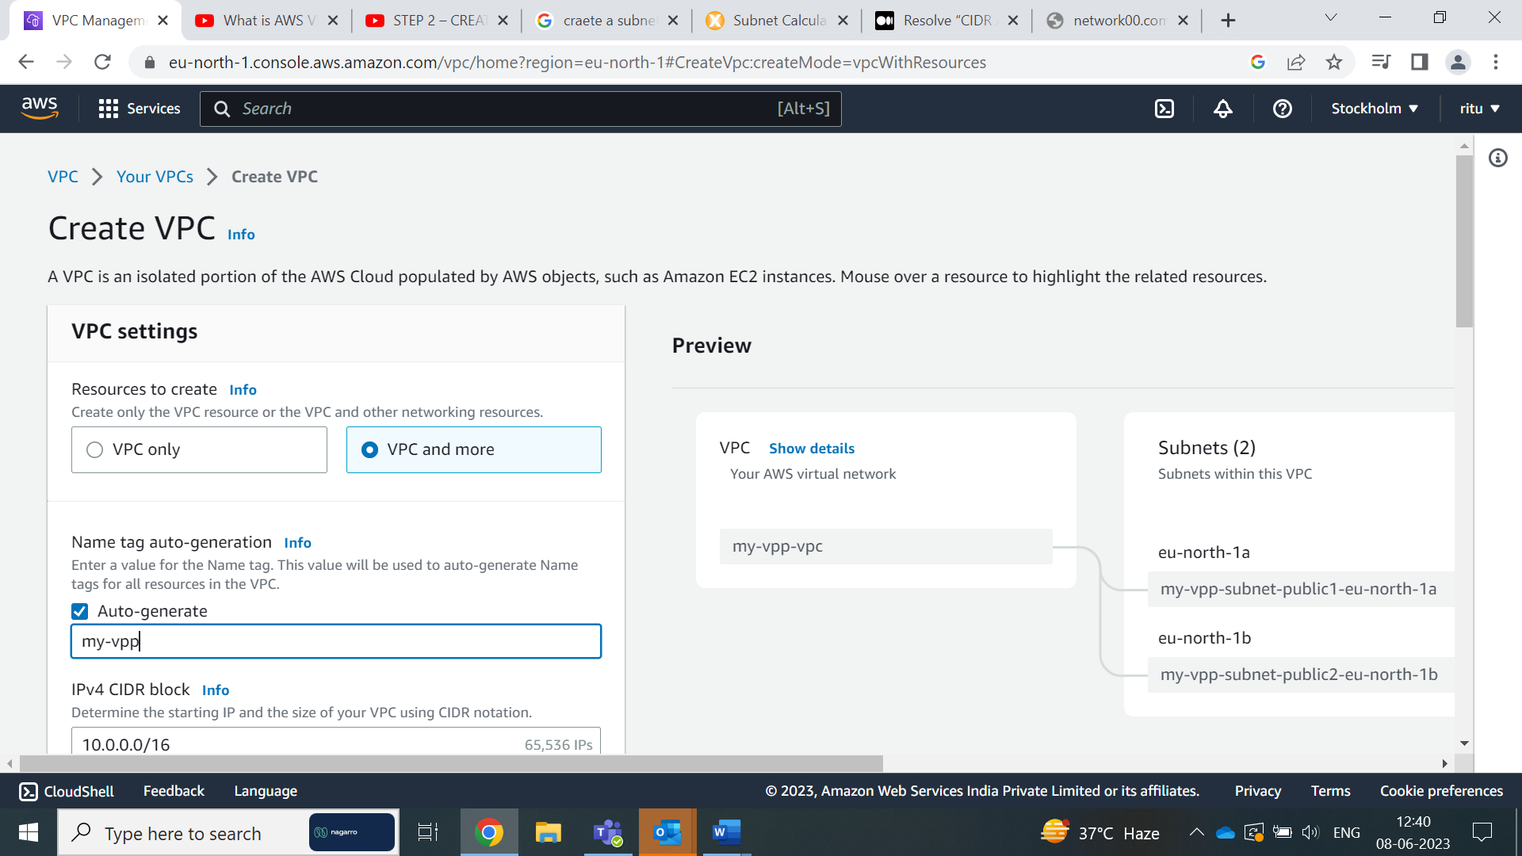

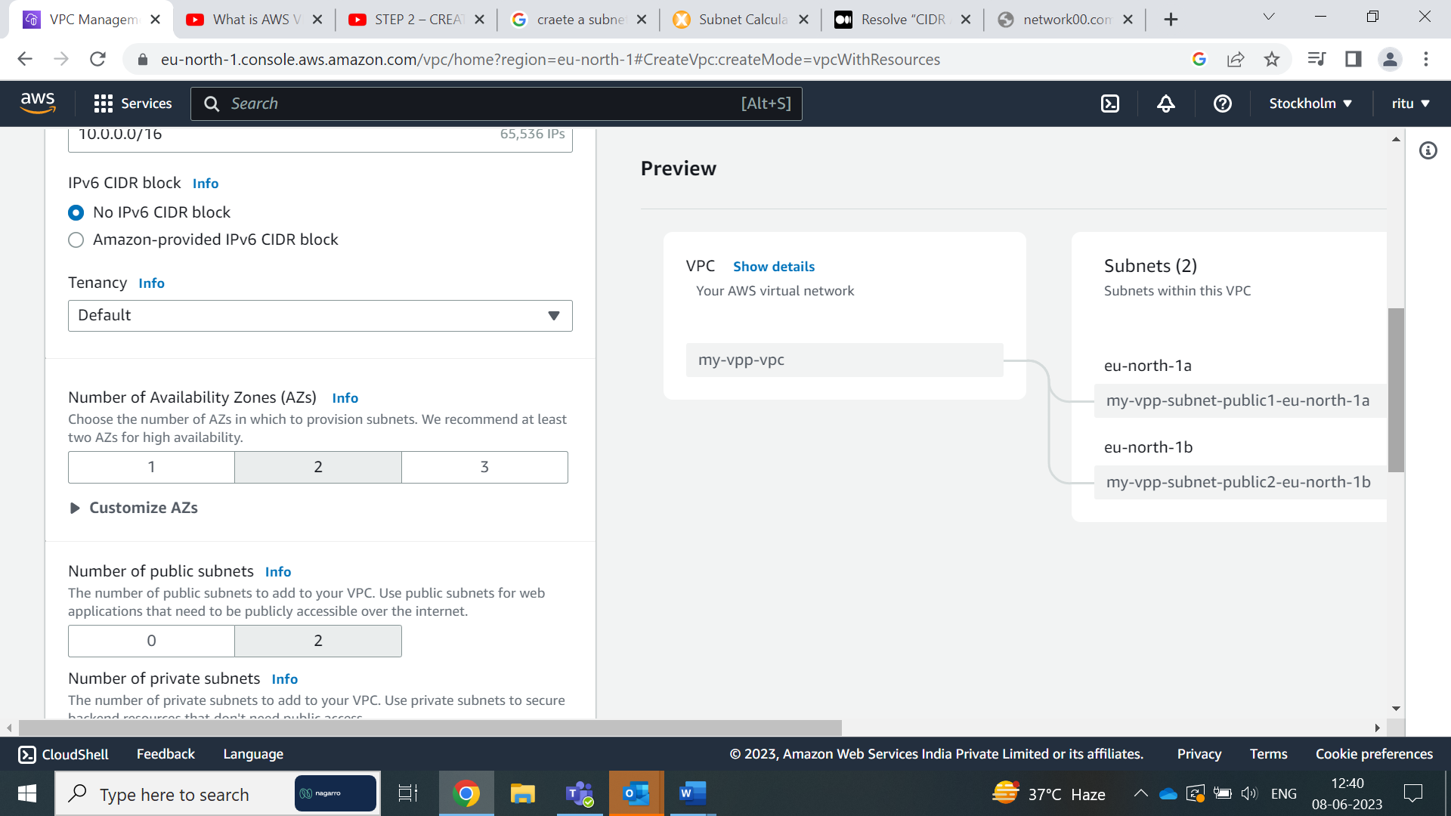

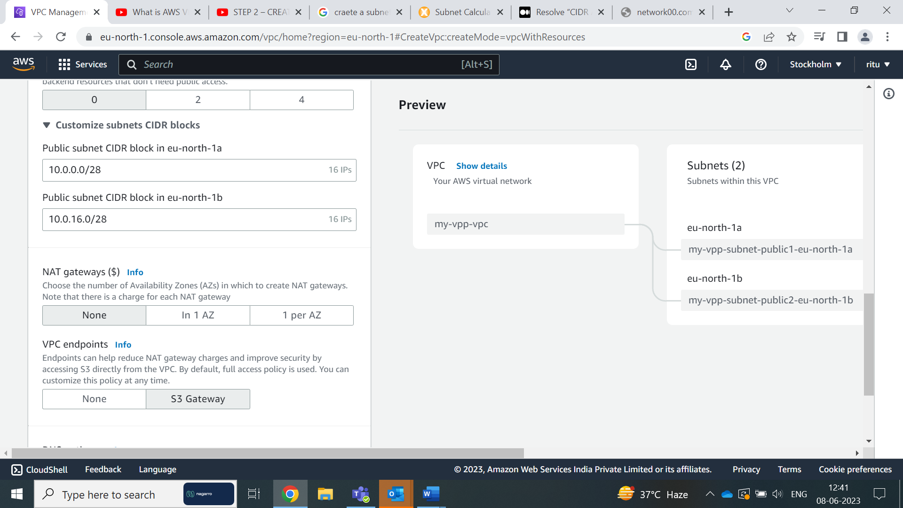

Click on VPC

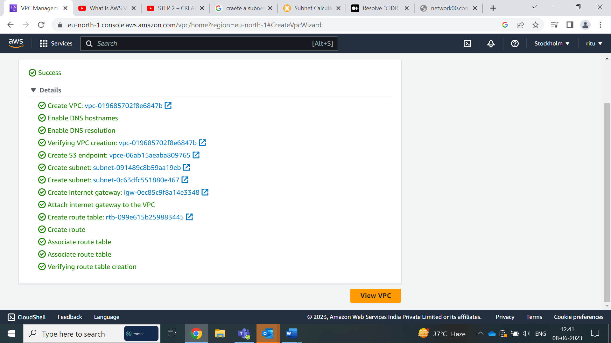

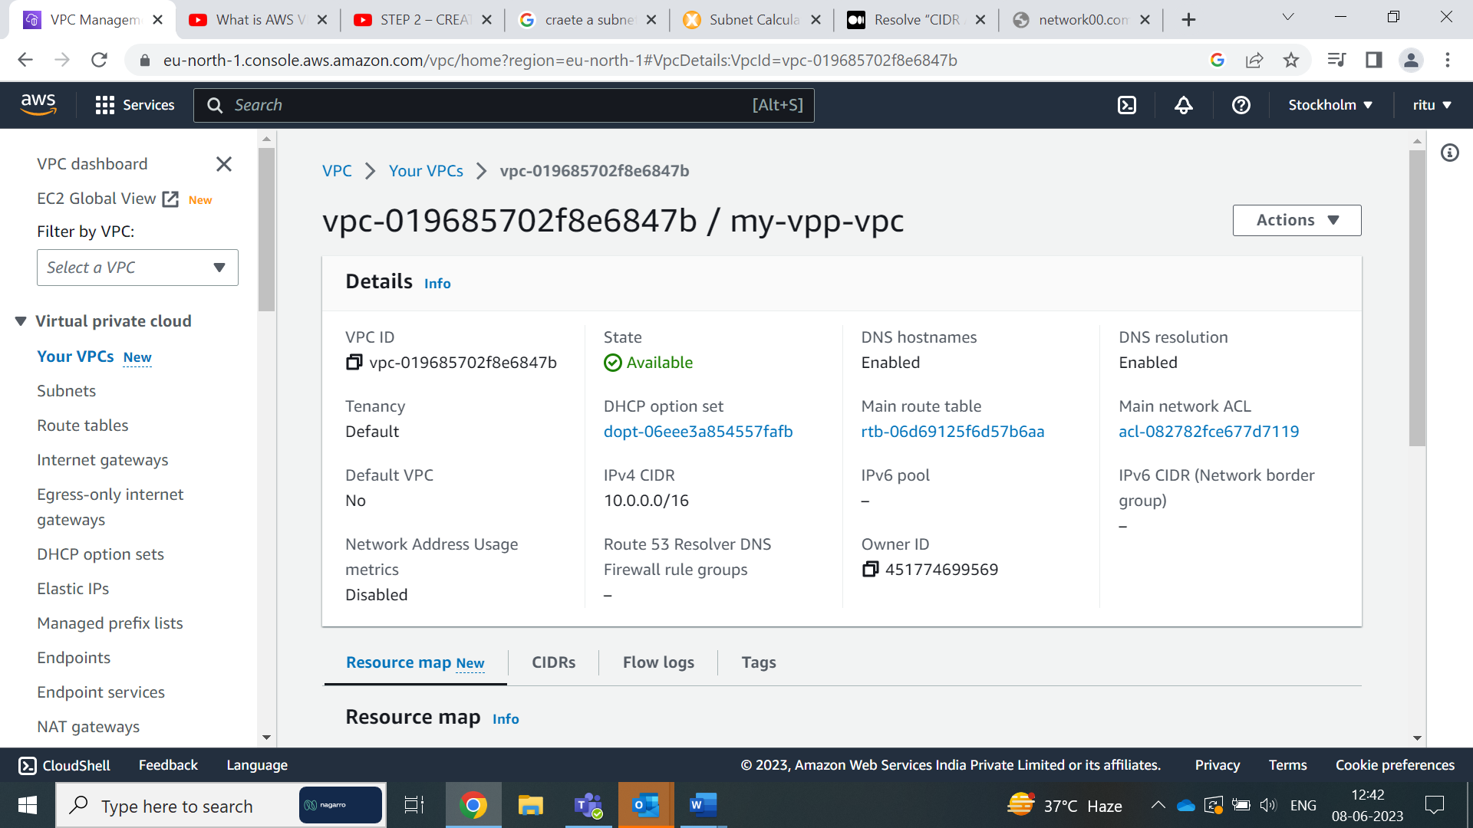

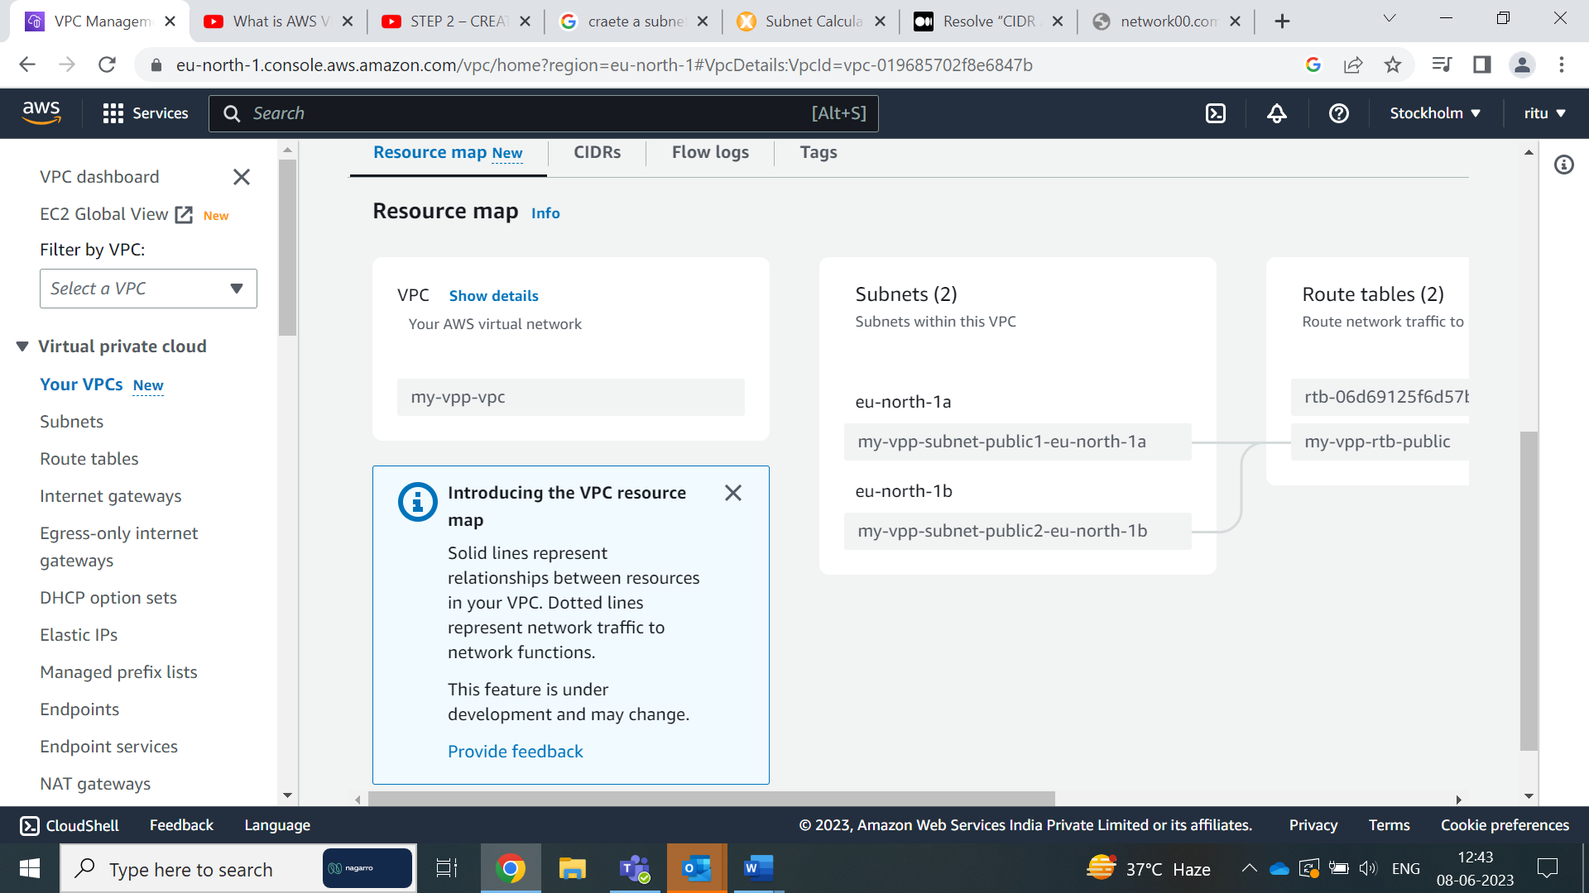

**Create a Lambda that should trigger as soon as you upload a file in the S3 bucket.**

**Function should be able to print the name of the file uploaded in the function.**

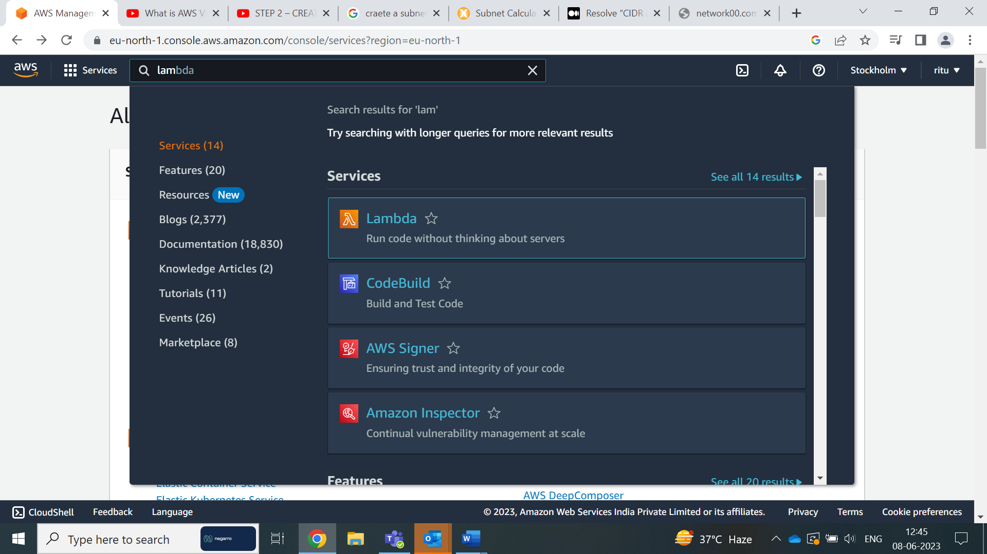

Go to the AWS Management Console and navigate to the Lambda service

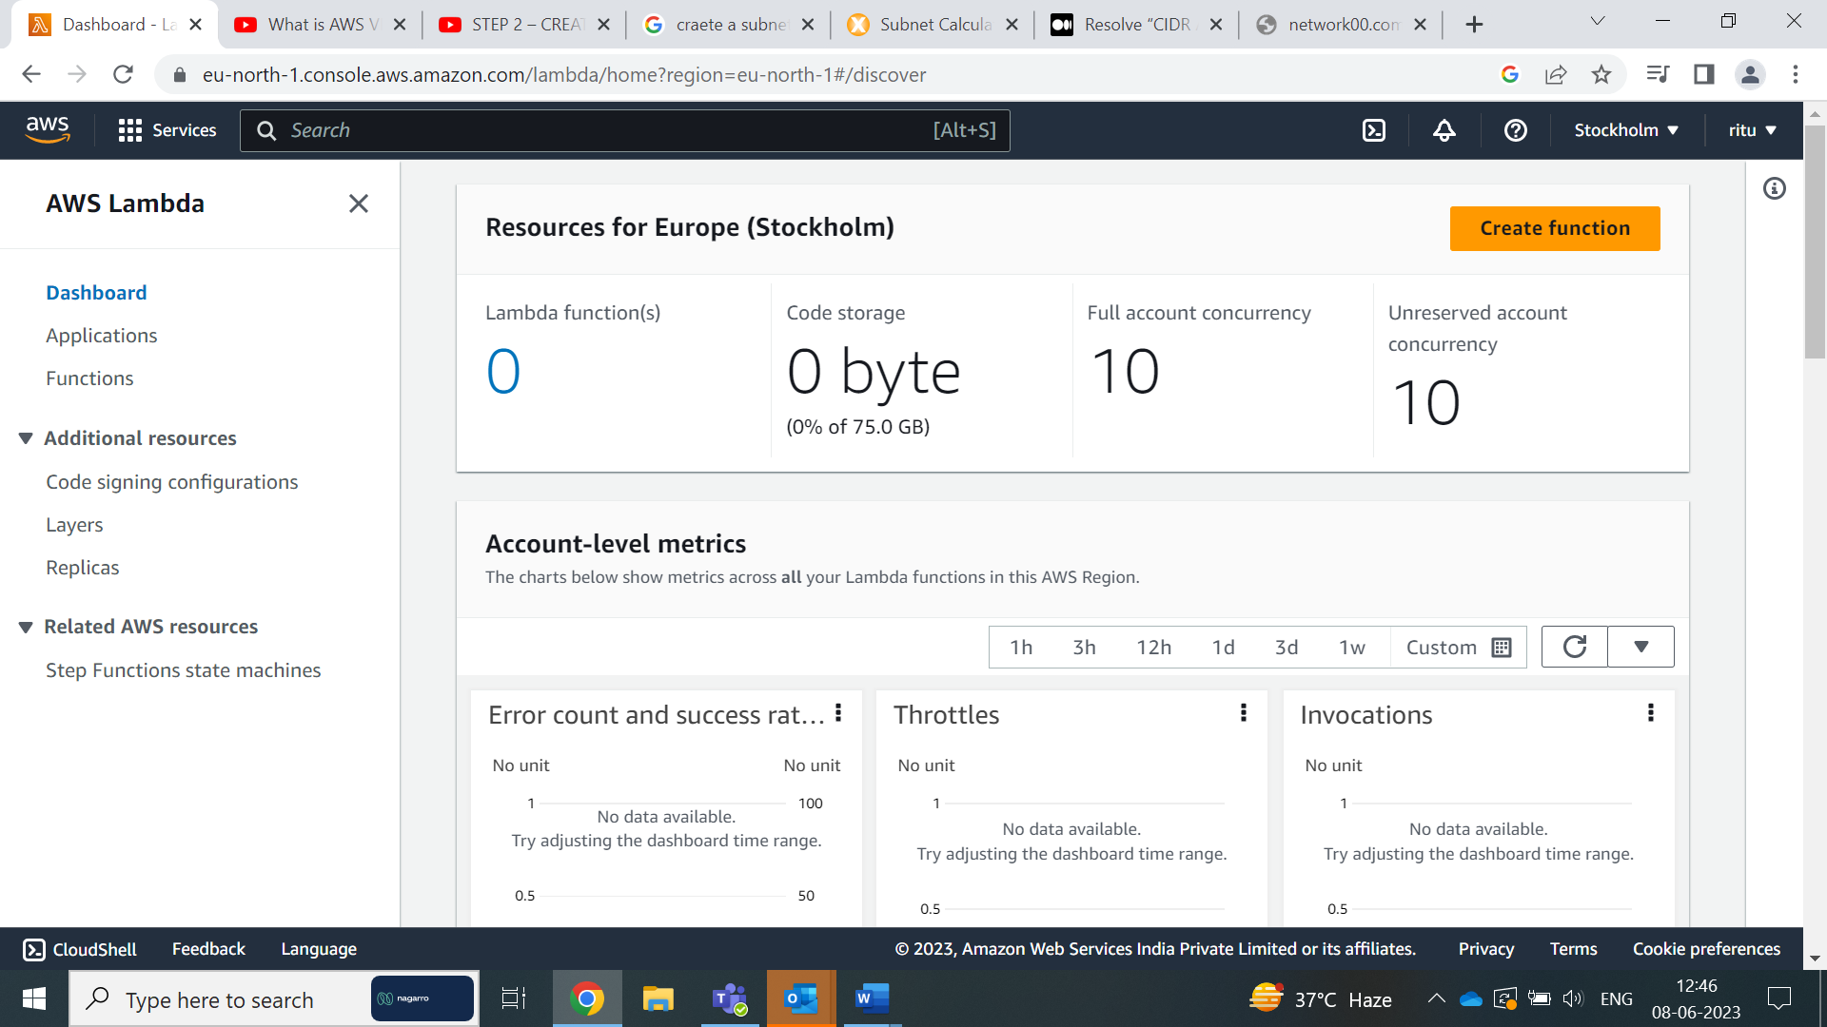

Click on "Create function"

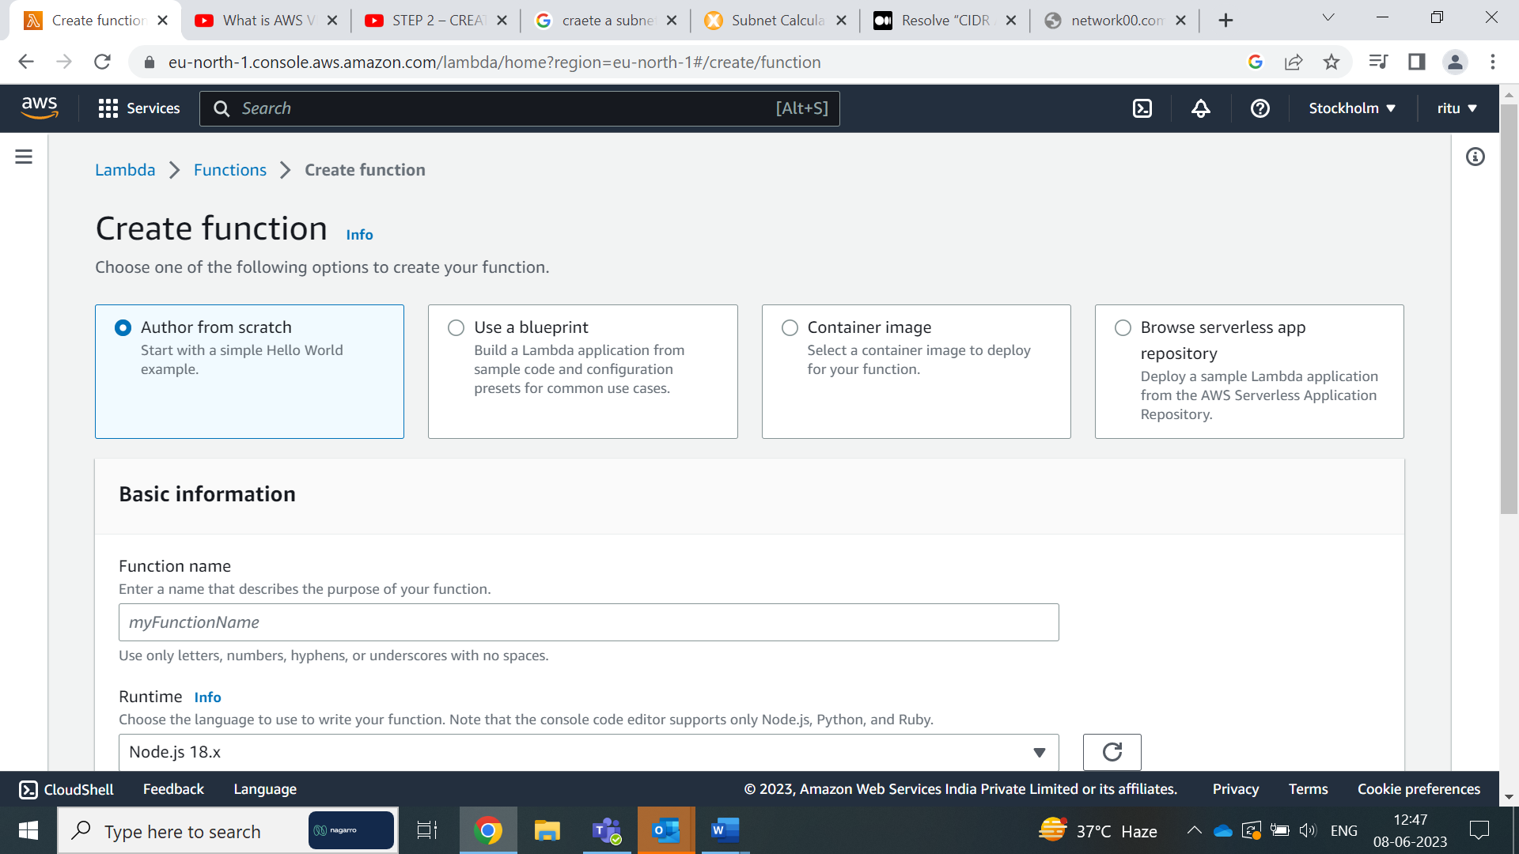

choose "Author from scratch"

Give your function a name and select the runtime as "Python 3.x"

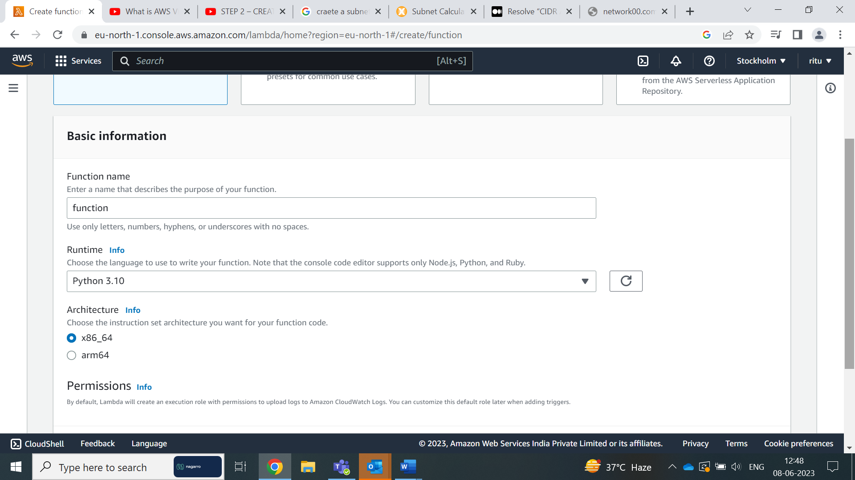

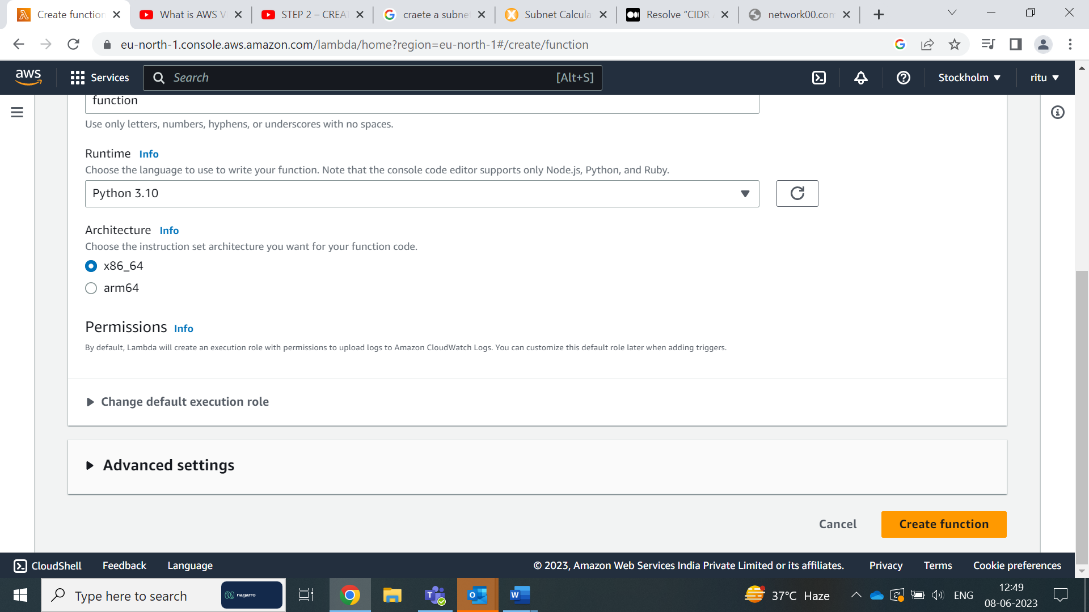

Click on "Create function" to create the Lambda function

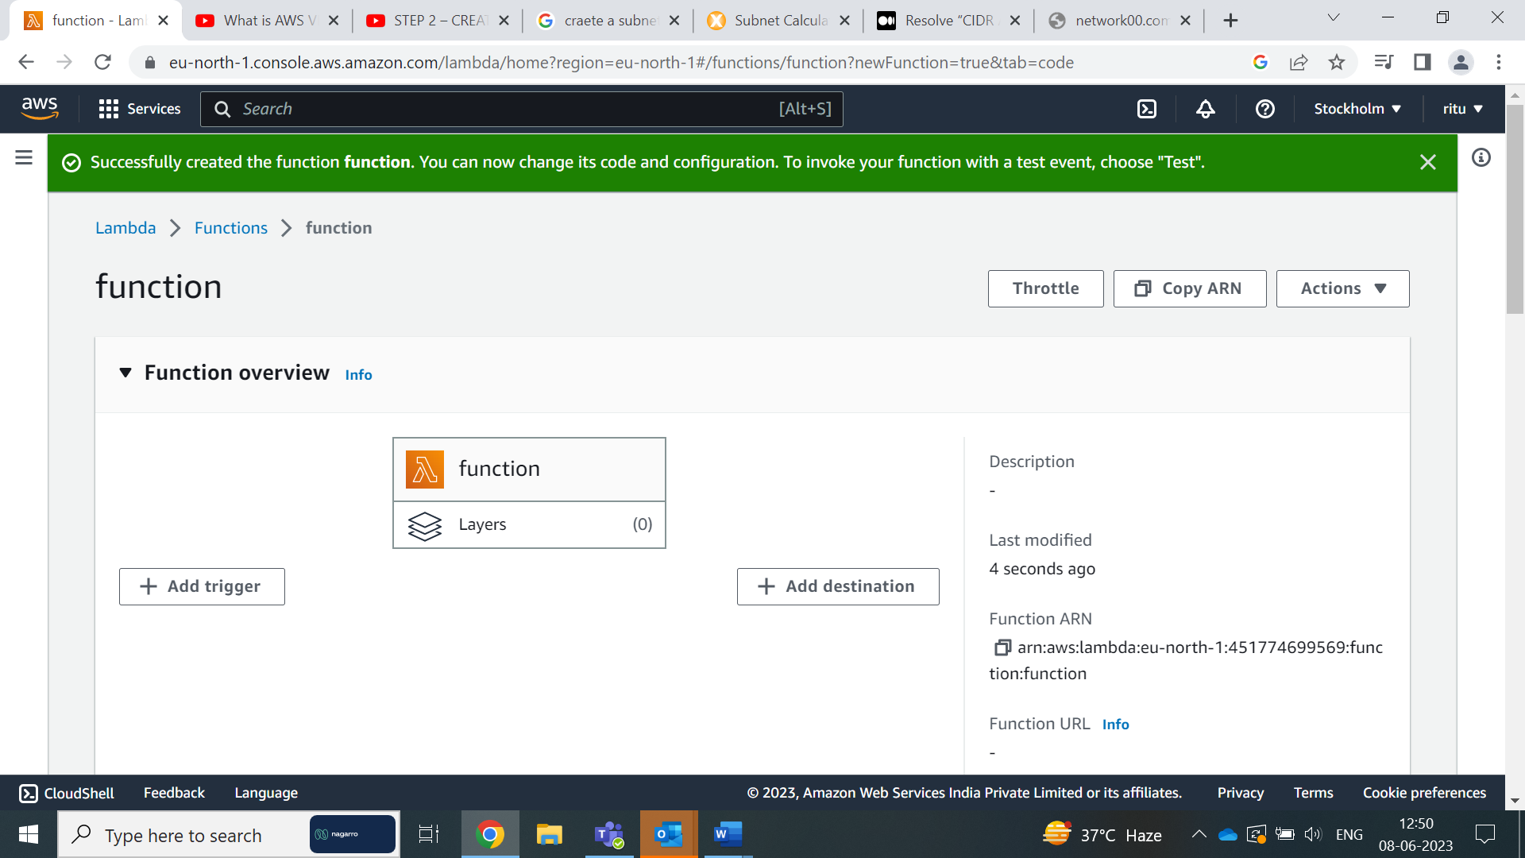

Click on Add triggers

Before Adding trigger we need to create the bucket in S3 for that :

Go to the AWS Management Console and navigate to the Amazon S3 service

Click on buckets

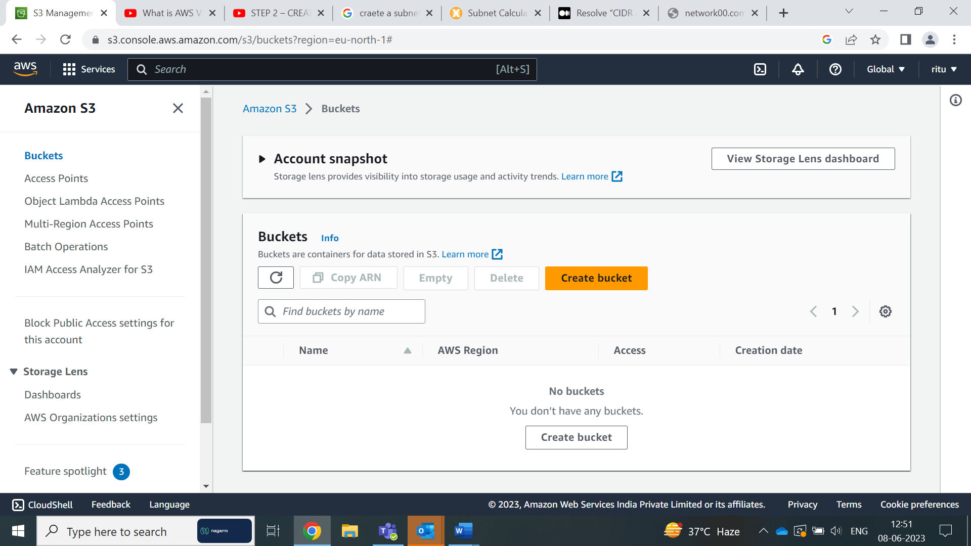

Click on “Create Bucket”

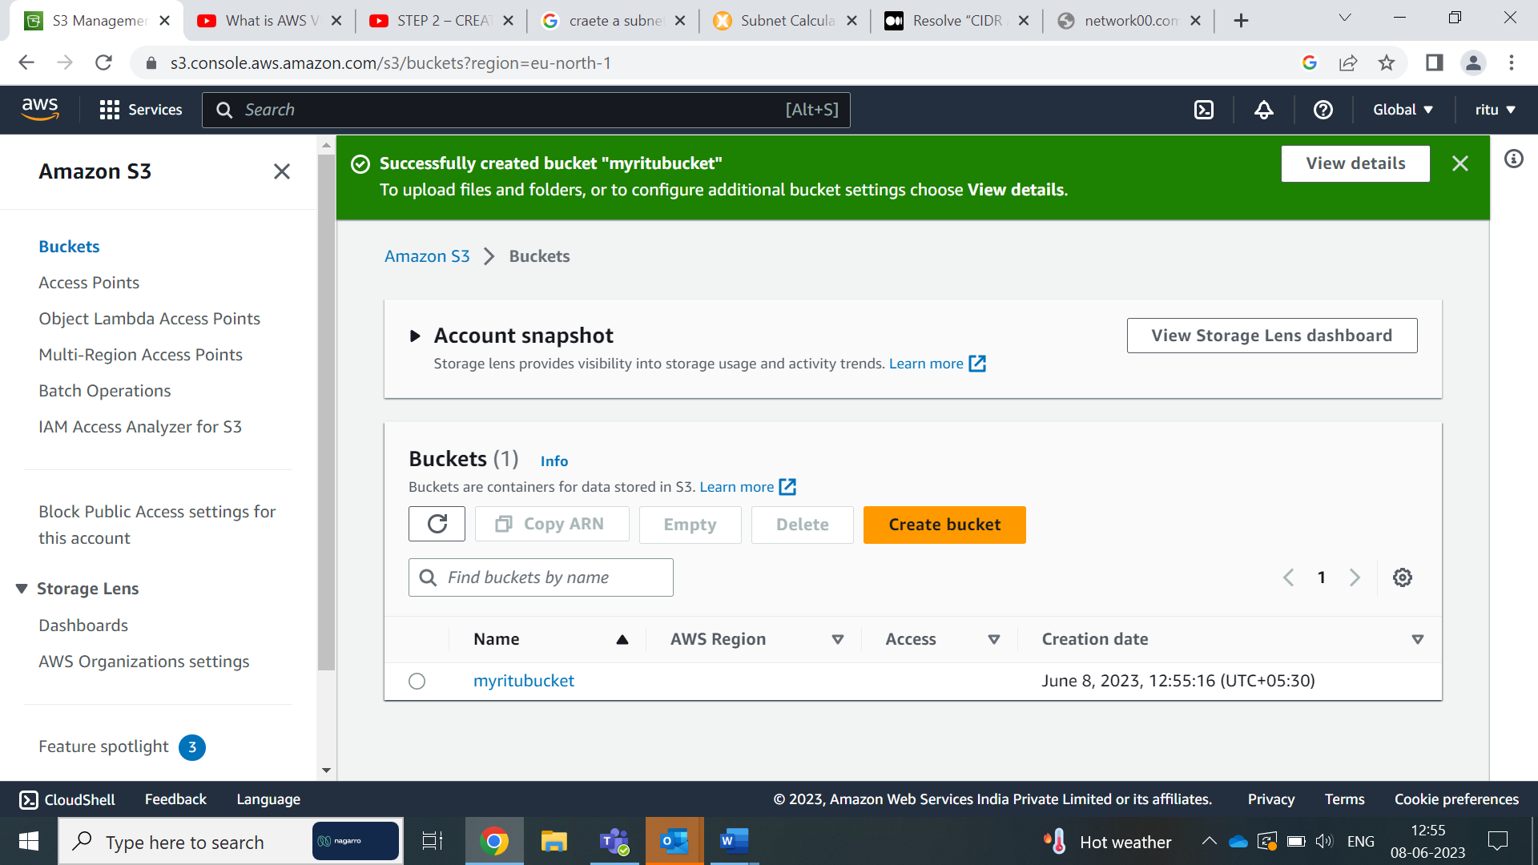

Now in Add Trigger Choose the type as S3 and choose the bucket we have created

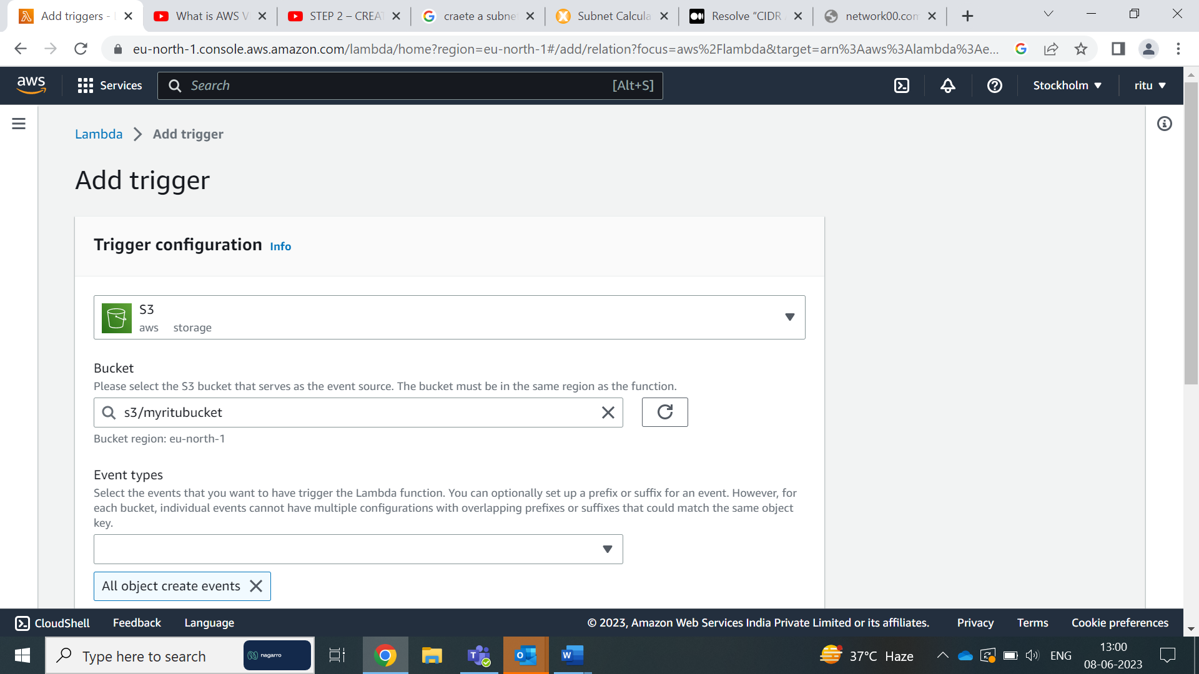

Select the Event Types

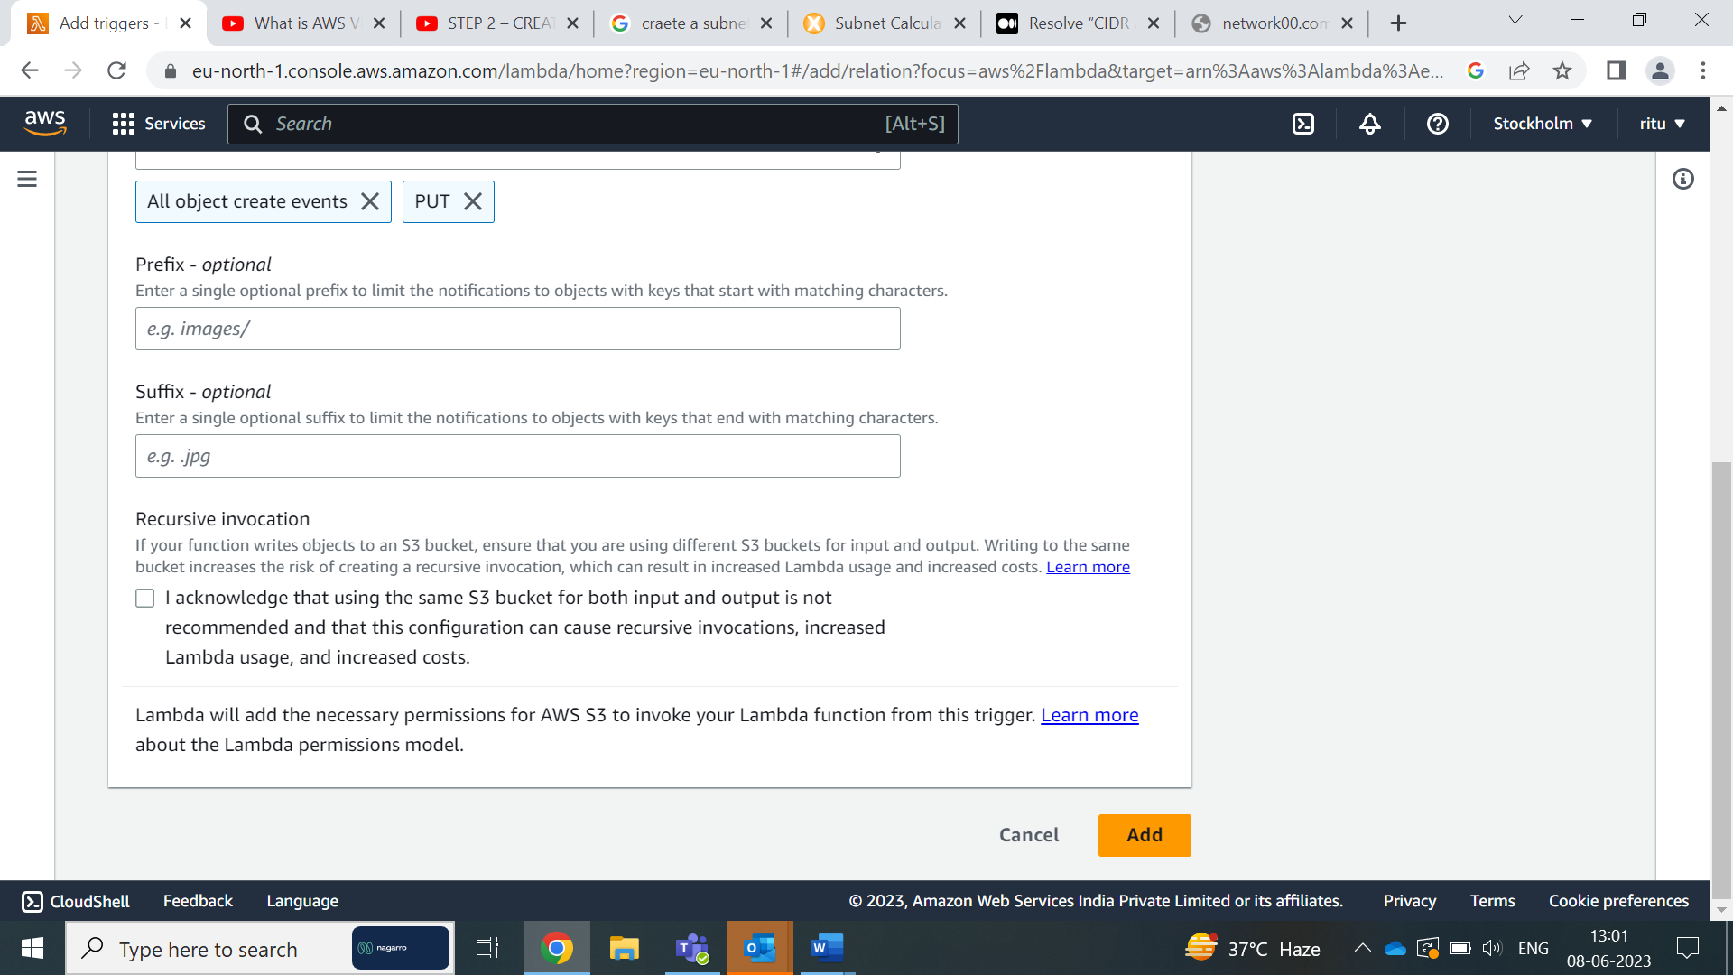

Click on Add

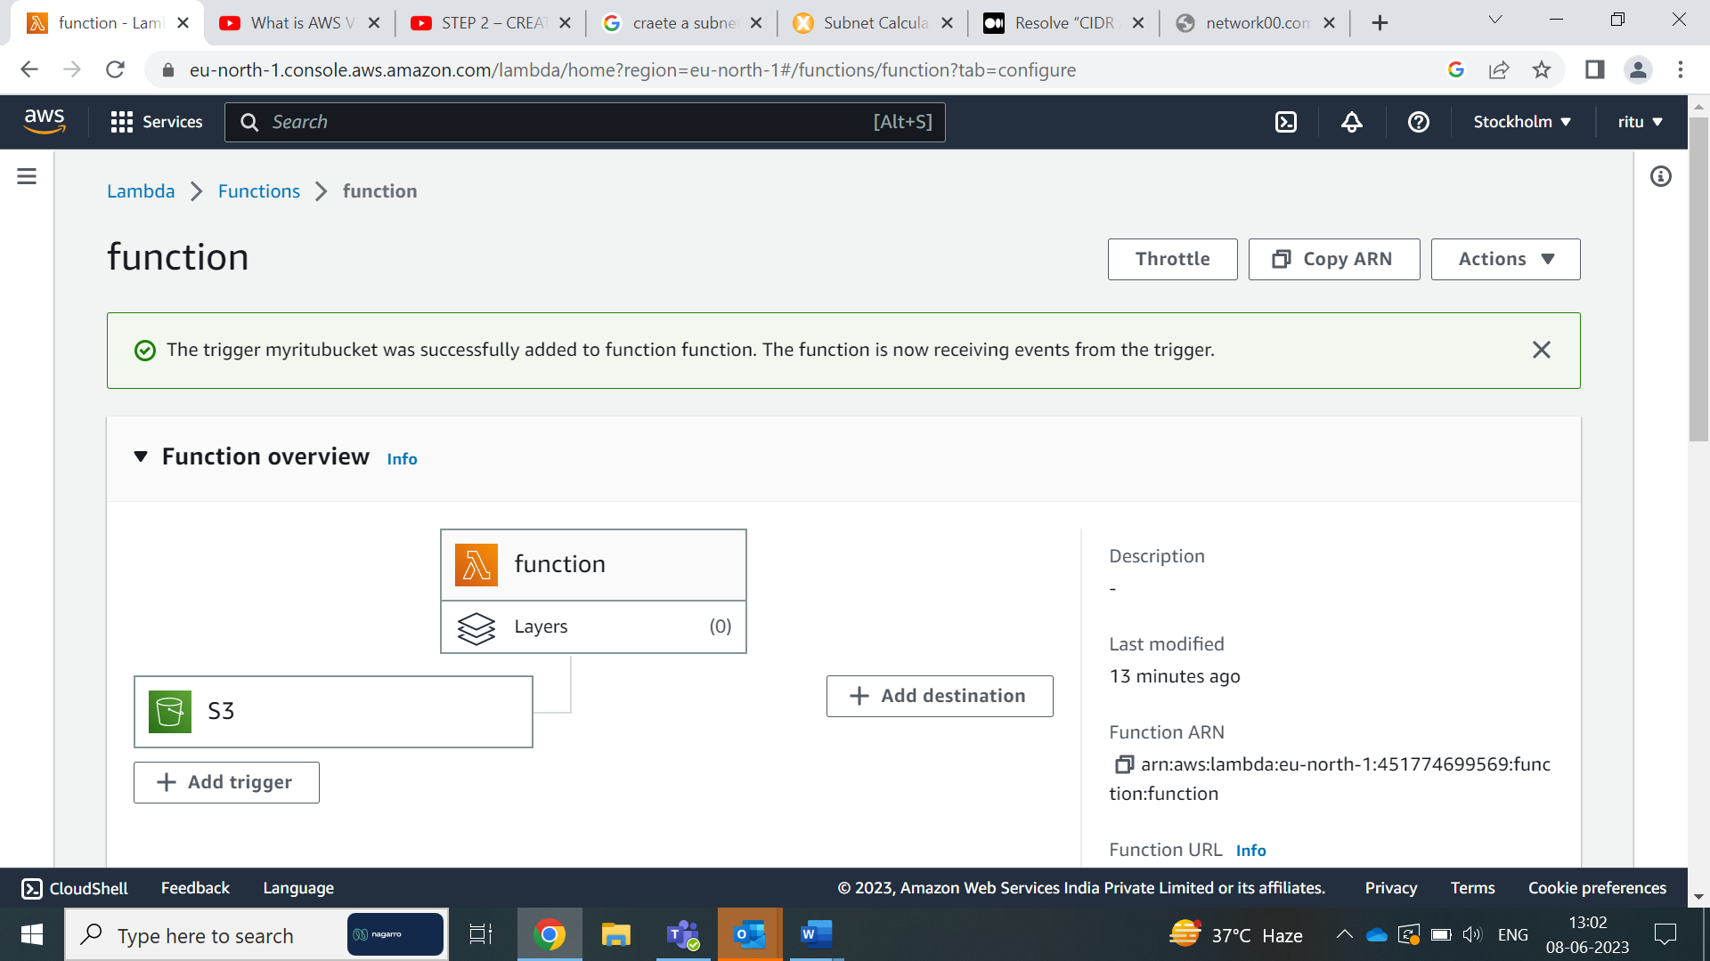

Change the code accordingly and click on update and deploy

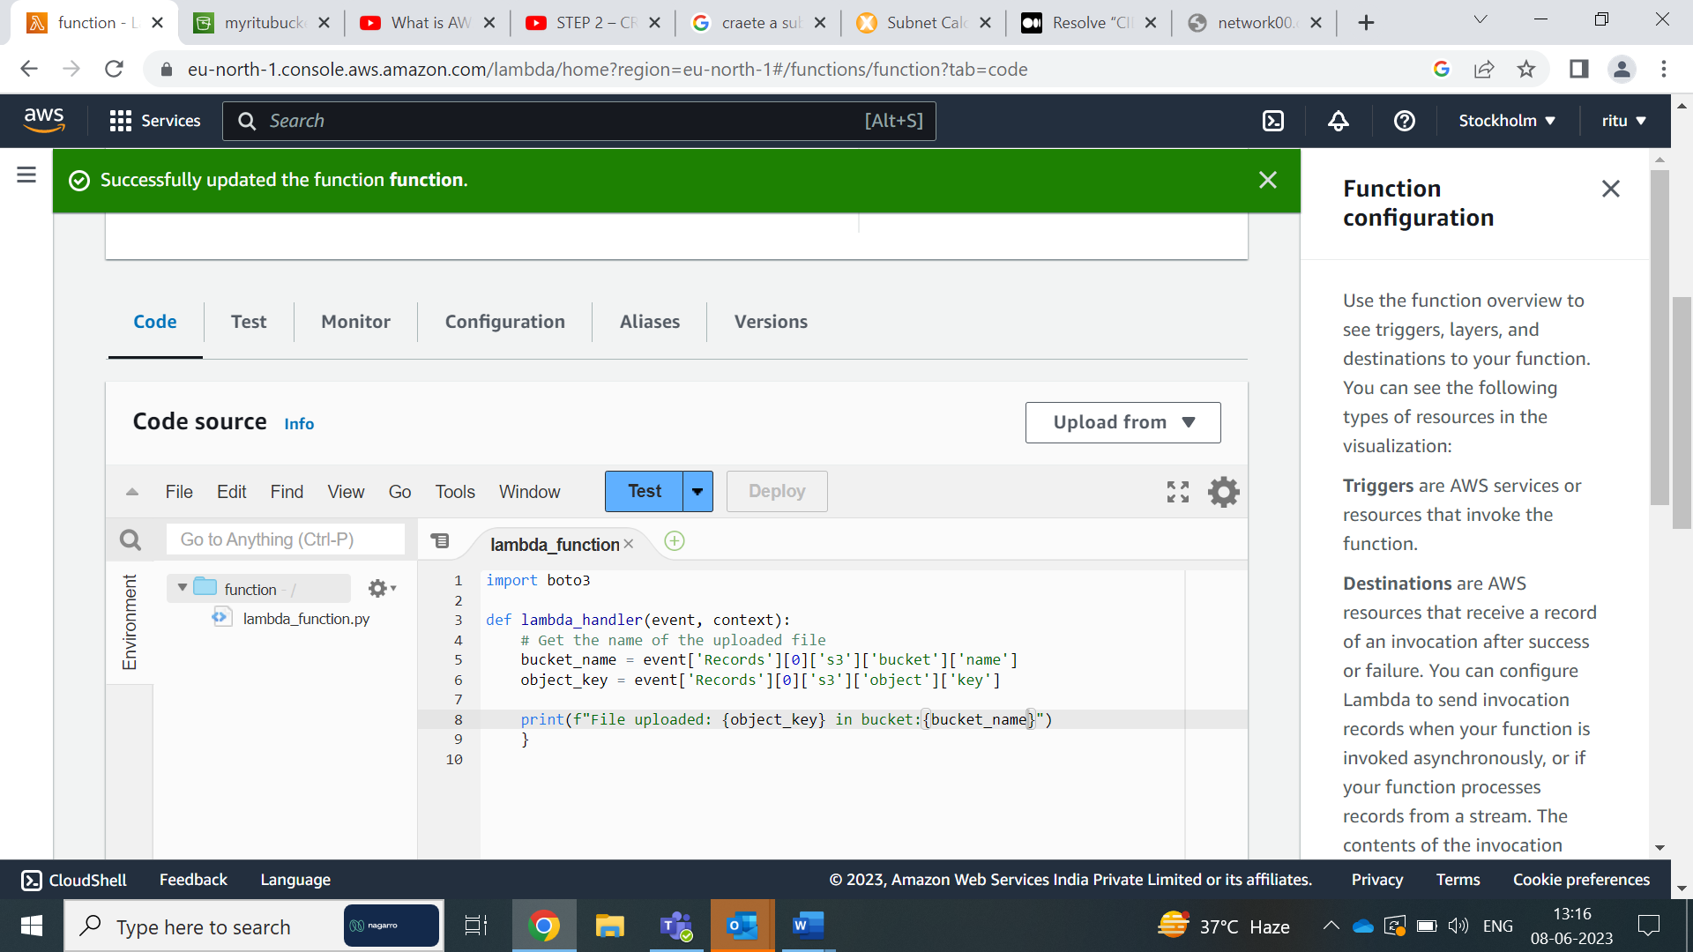

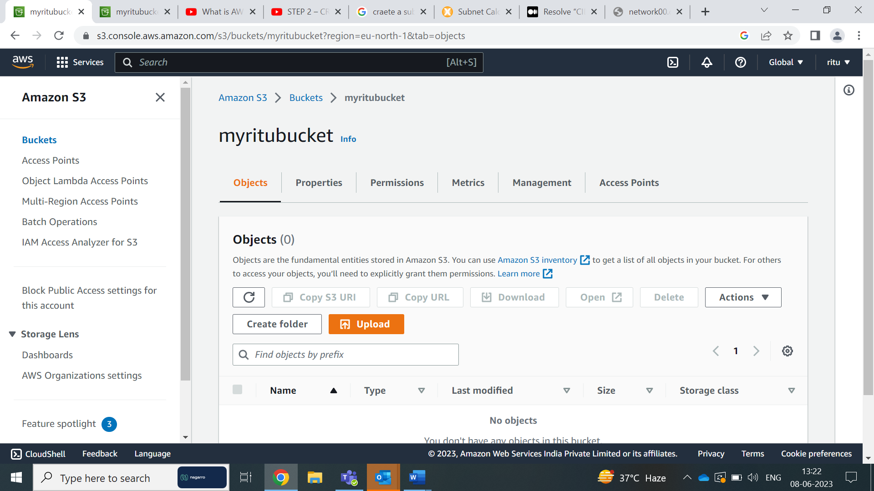

Now Upload the file in the bucket as follow.

Click on upload and select the file and click on upload

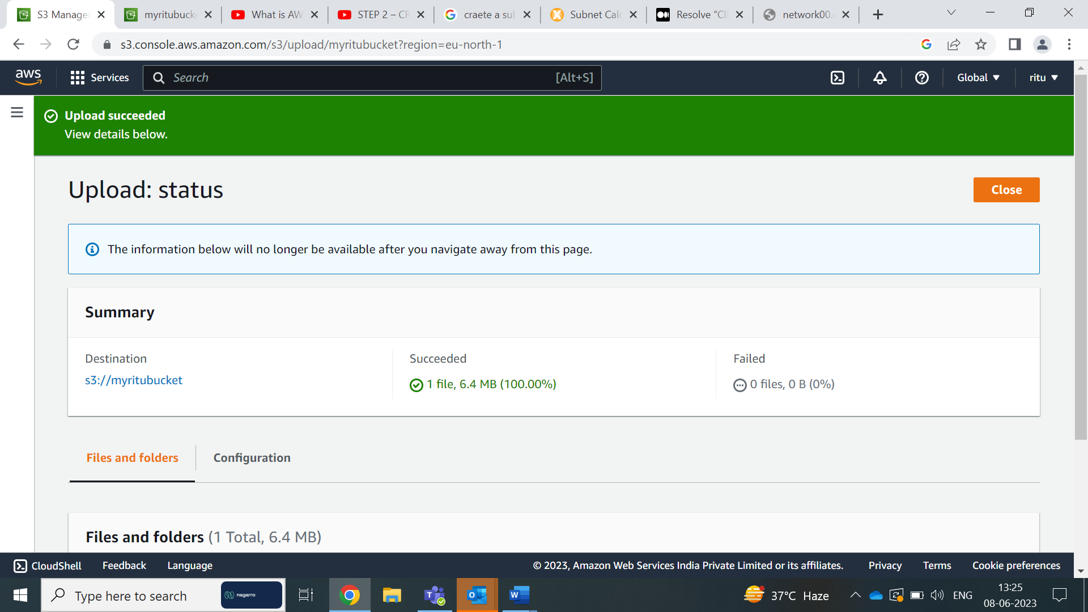

Now go to CloudWatch service

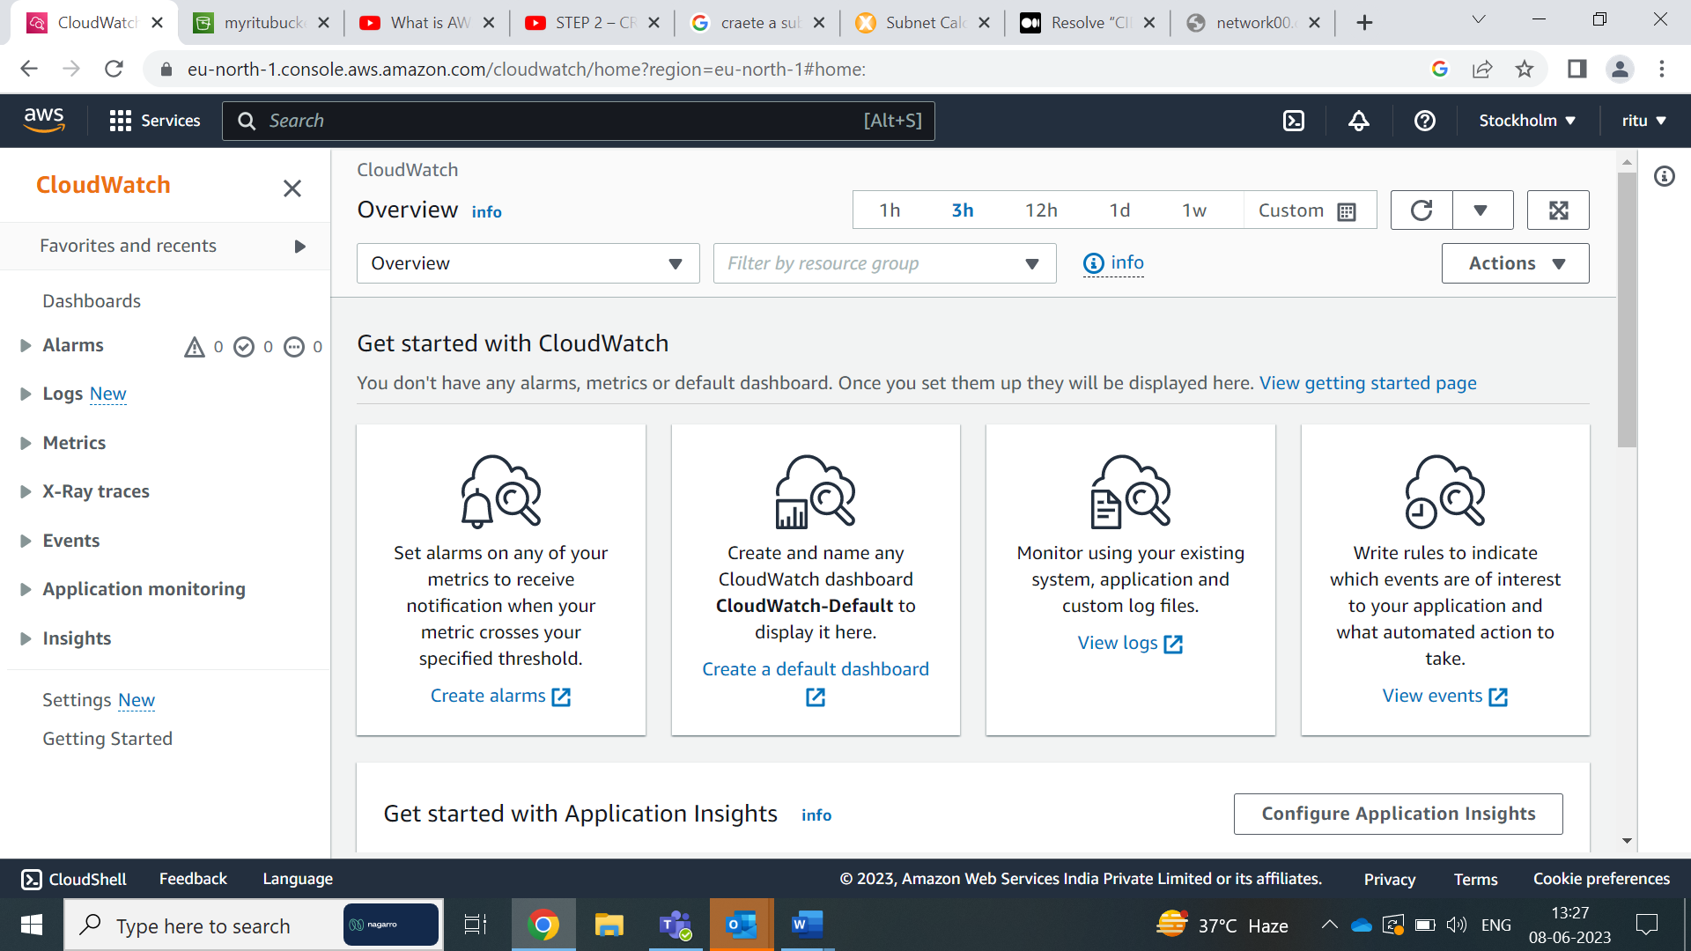

Click on log groups

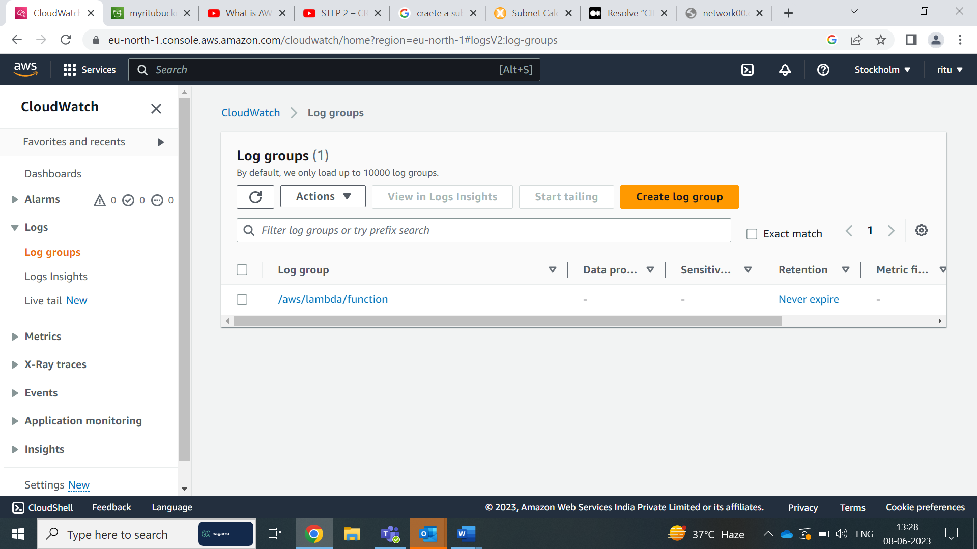

We can observe the logs of the function and click on function

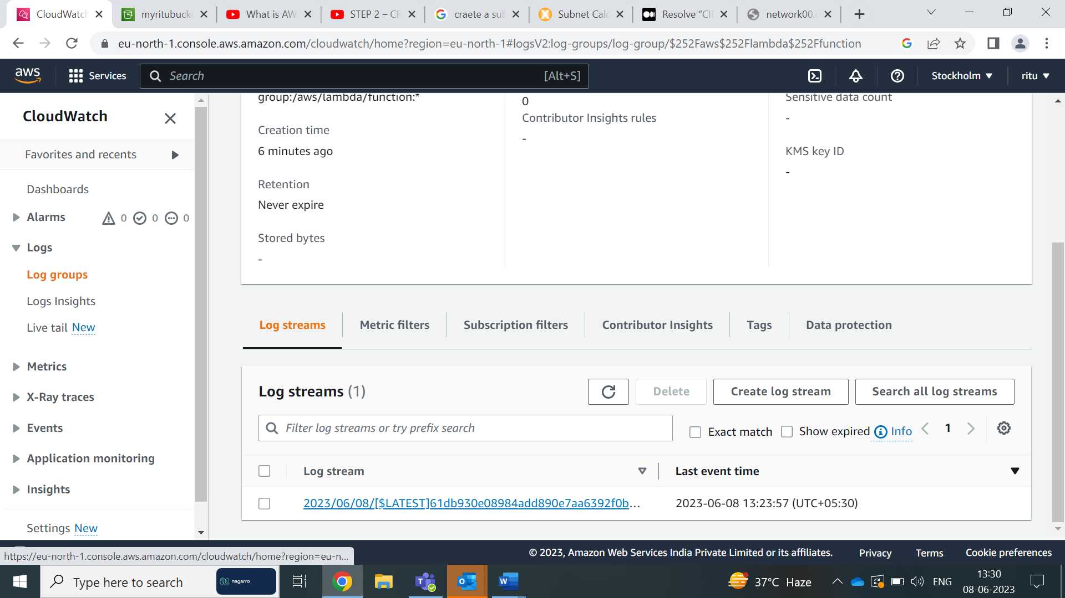

Click on log stream

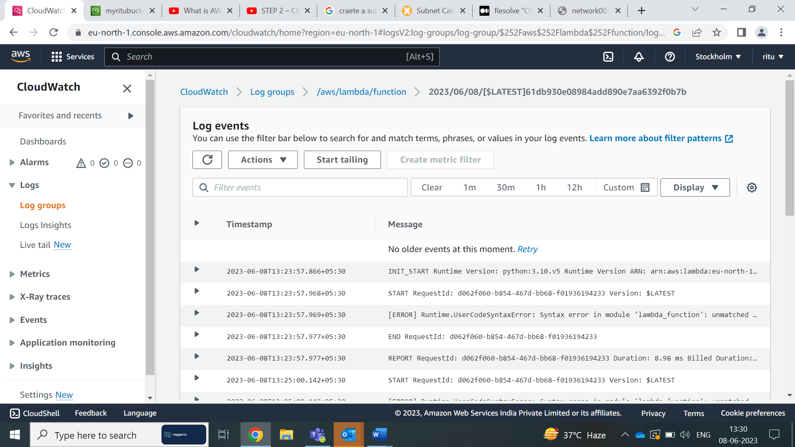

We can observe the details of the logs of the function and Name of the that uploaded in S3 bucket

**Inside one of the subnets, create a VM and deploy an application code inside it (any existing application created by you before). Make sure to use appropriate NACLs and SGs.**

Sign in to the AWS Management Console.

Open the Amazon EC2 service.

Click on "Launch Instances" to start the instance creation wizard

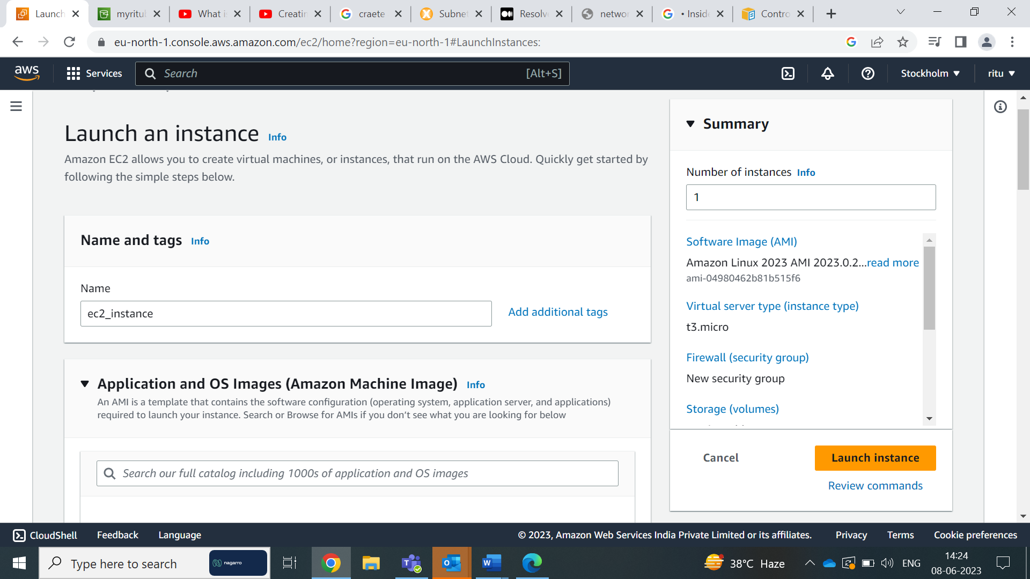

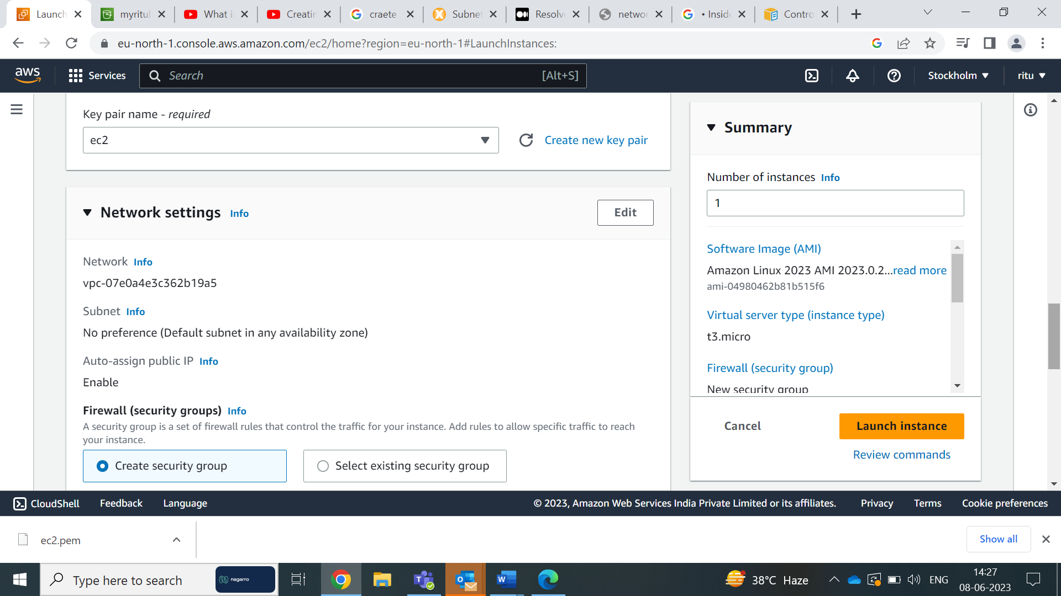

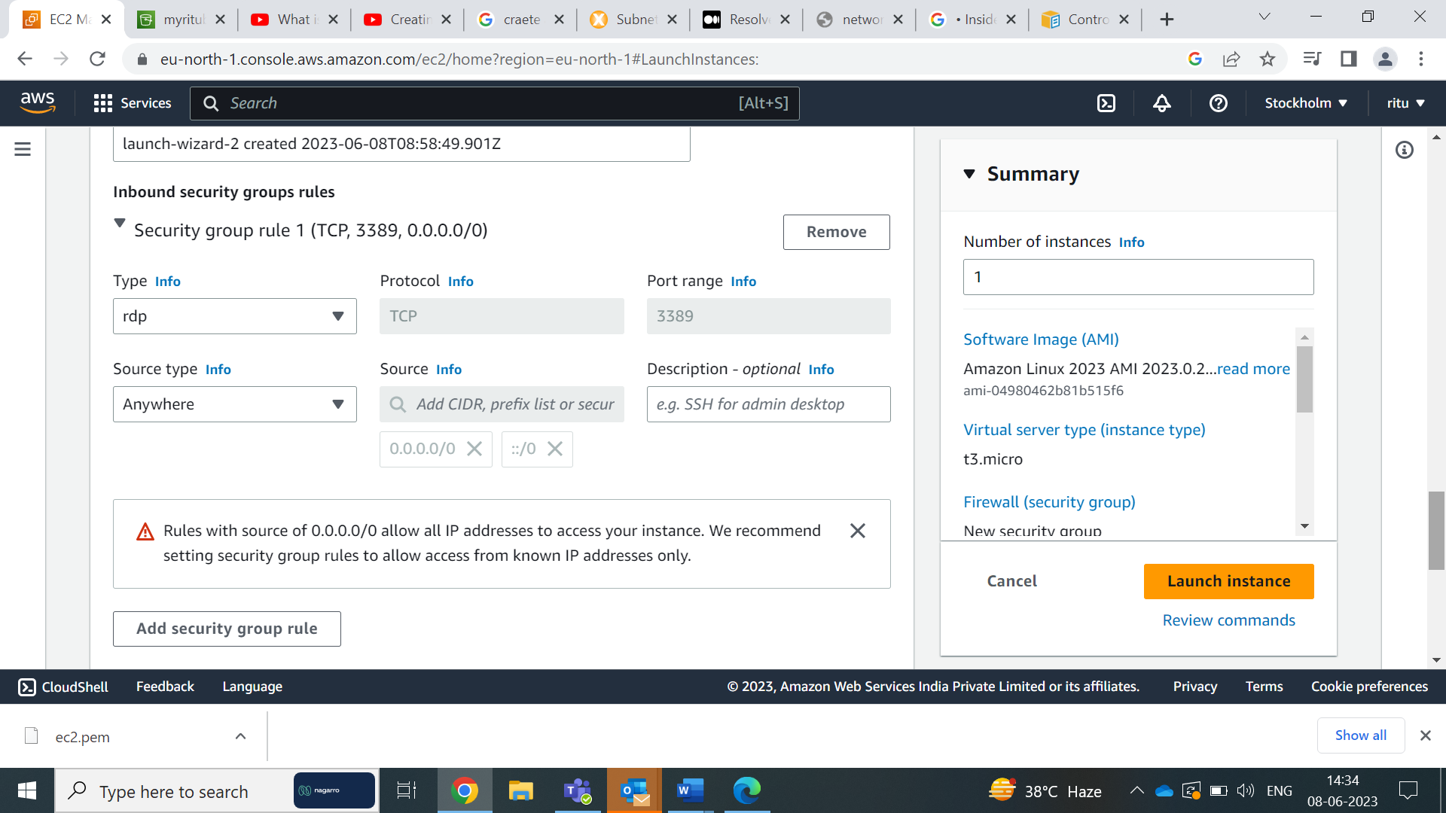

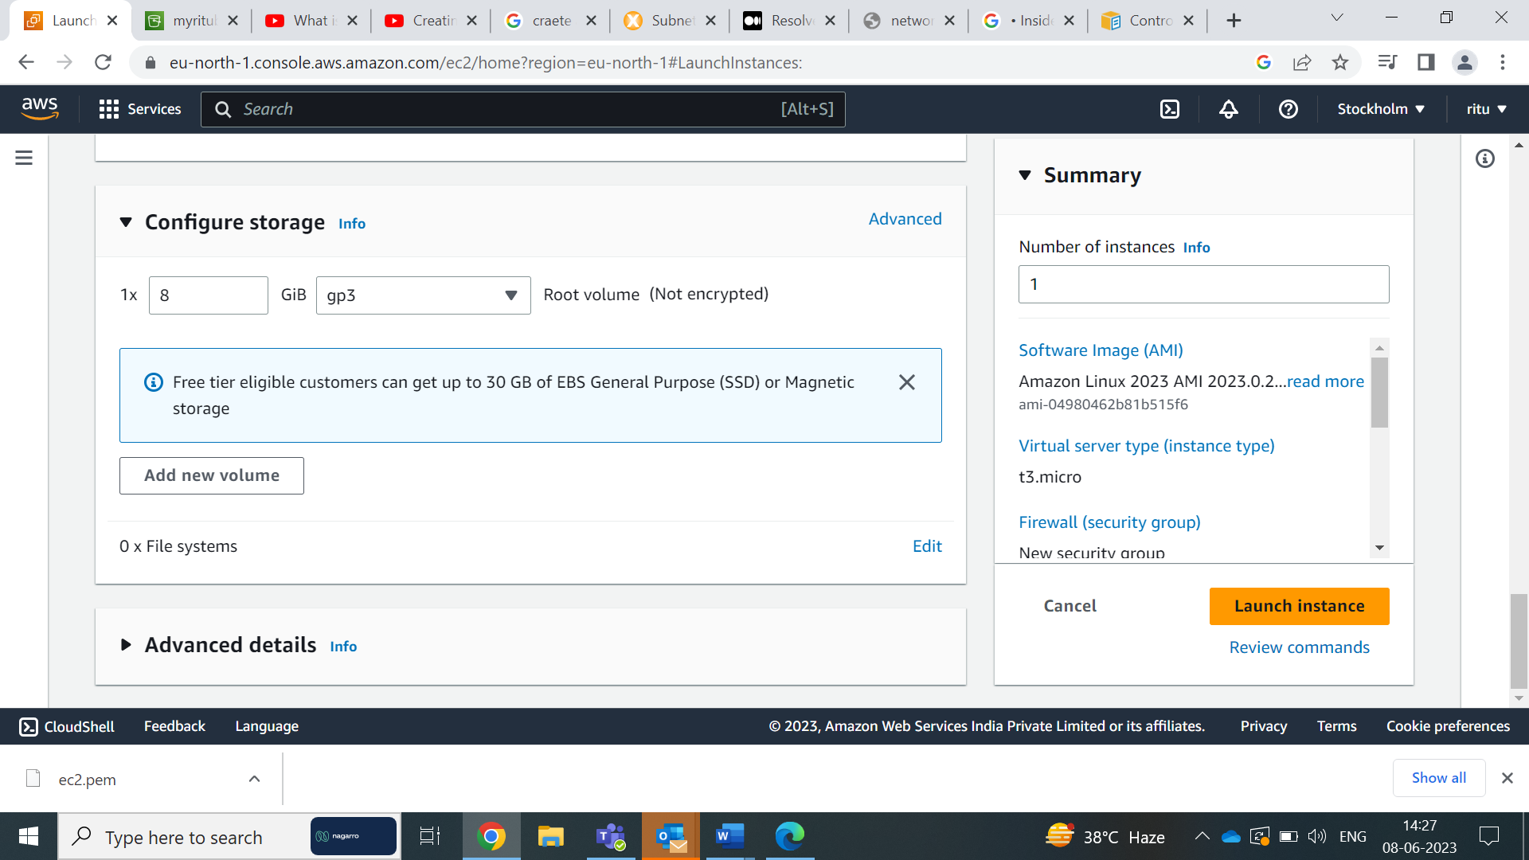

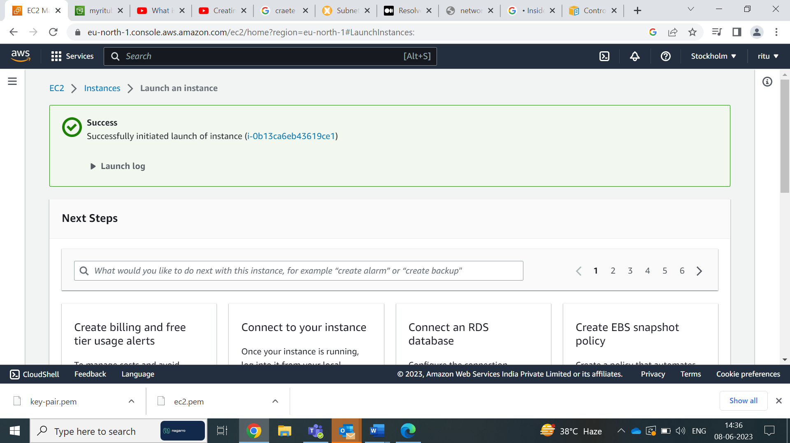

By clicking the connect start the ec2 instance cli,and download the systemctl httpd.

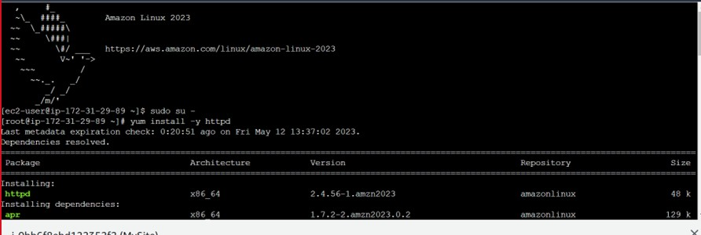

Create a direcectory aws_assg. And wget github file link.

And then run mv*/var/www/html/

Cd /var/www/html

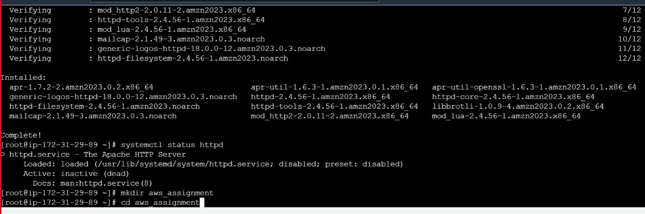

And then run the command systemctl start httpd,and the application will start.

